**DAILY ONLINE ACTIVITIES SUMMARY**

|  |  |  |  |  |  |  |  |
| --- | --- | --- | --- | --- | --- | --- | --- |
| **Date:** | **08/06/2020** | | | | **Name:** | **Churashma** | |
| **Sem & Sec** | **4th SEM 'A' Section** | | | | **USN:** | **4AL18CS019** | |
| **Online Test Summary** | | | | | | | |
| **Subject** | | **Complex analysis,probability and statistical method** | | | | | |
| **Max. Marks** | | **30** | | **Score** | | **20** | |
| **Certification Course Summary** | | | | | | | |
| **Course** | **Introduction to Ethical hacking** | | | | | | |
| **Certificate Provider** | | | **greatlearning academy** | **Duration** | | | **4.0 hours** |
| **Coding Challenges** | | | | | | | |
| **Problem statement 1: Write a Java Program to check whether the given matrix is magic square or not.**  **Problem statement 2 : C Program to Generate All the Set Partitions of n Numbers Beginning from 1 and so on** | | | | | | | |
| **Status: completed** | | | | | | | |
| **Uploaded the report in Github** | | | | **yes** | | | |
| **If yes Repository name** | | | | **https://github.com/Churashma/Lockdown-coding** | | | |
| **Uploaded the report in slack** | | | | **yes** | | | |

ONLINE TEST DETAILS: Maths test was scheduled from 09:30 am to 10:10 am .The portion for the IA was module 2 there were 30 questions and the time assigned was 40 minutes the questions were mcq type.

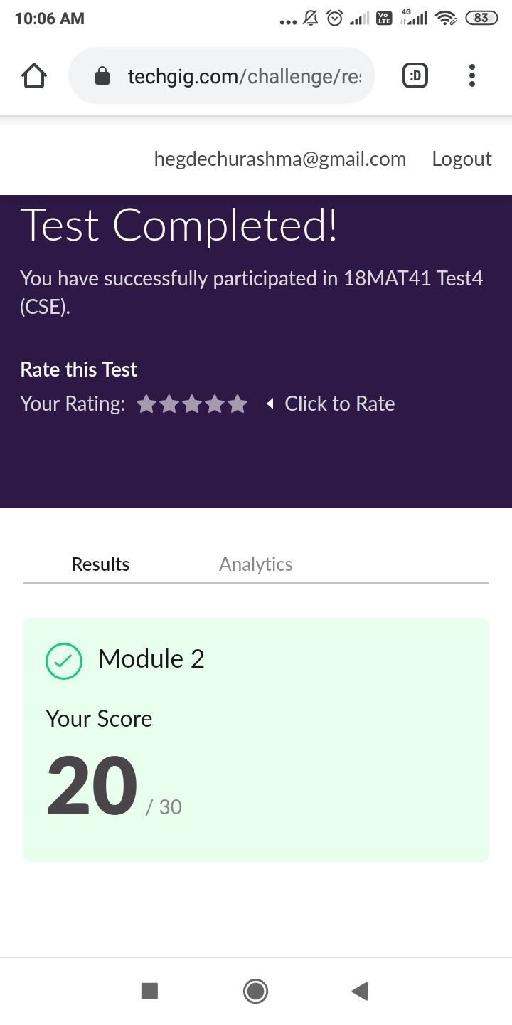

CERTIFICATION COURSE DETAILS: Today I studied about Domains and process implementation under ethical hacking and also I studied about ethical hacking in network architecture demonstration.In the dawn of international conflicts, terrorist organizations funding cybercriminals to breach security systems, either to compromise national security features or to extort huge amounts by injecting malware and denying access.Hacking is usually legal as long as it is being done to find weaknesses in a computer or network system for testing purpose. This sort of hacking is what we call Ethical Hacking.

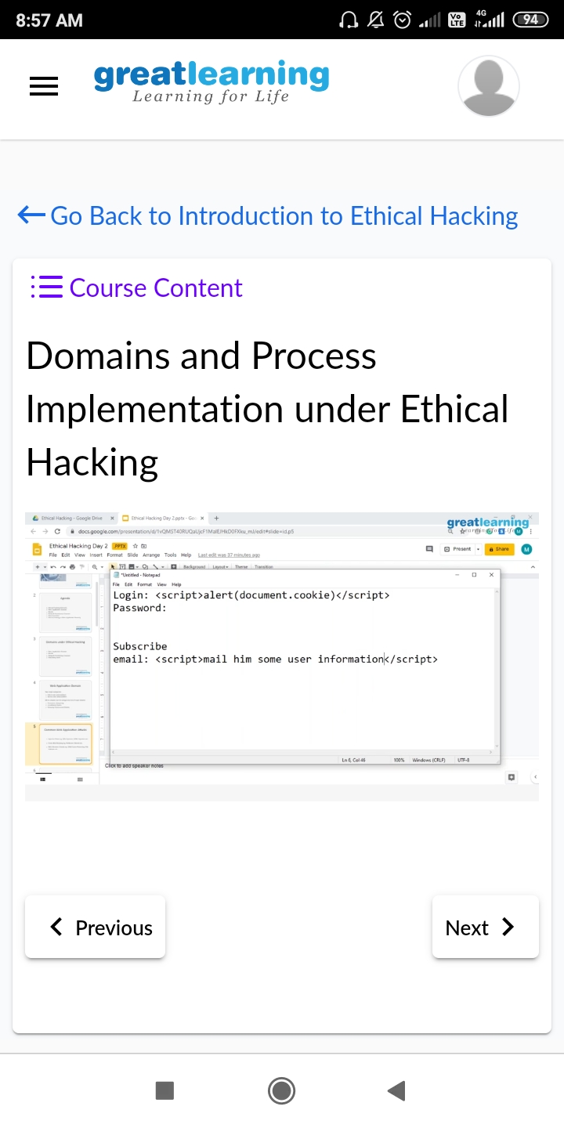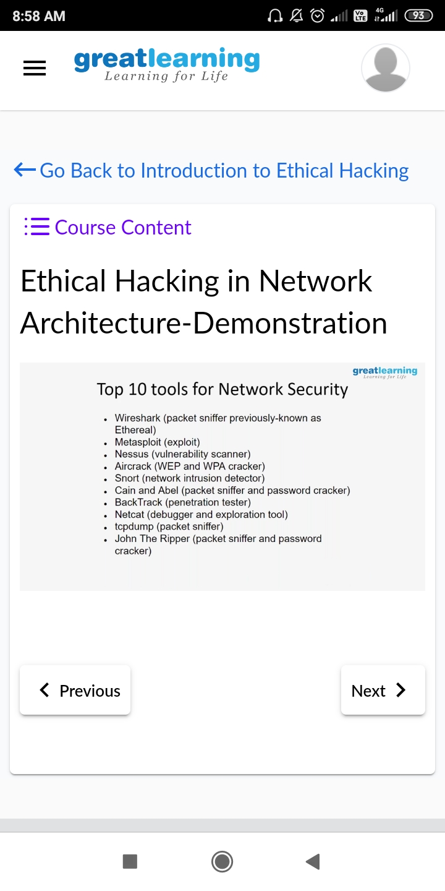

**CODING CHALLENGES DETAILS**:

**Problem statement 1:** Write a Java Program to check whether the given matrix is magic square or not.

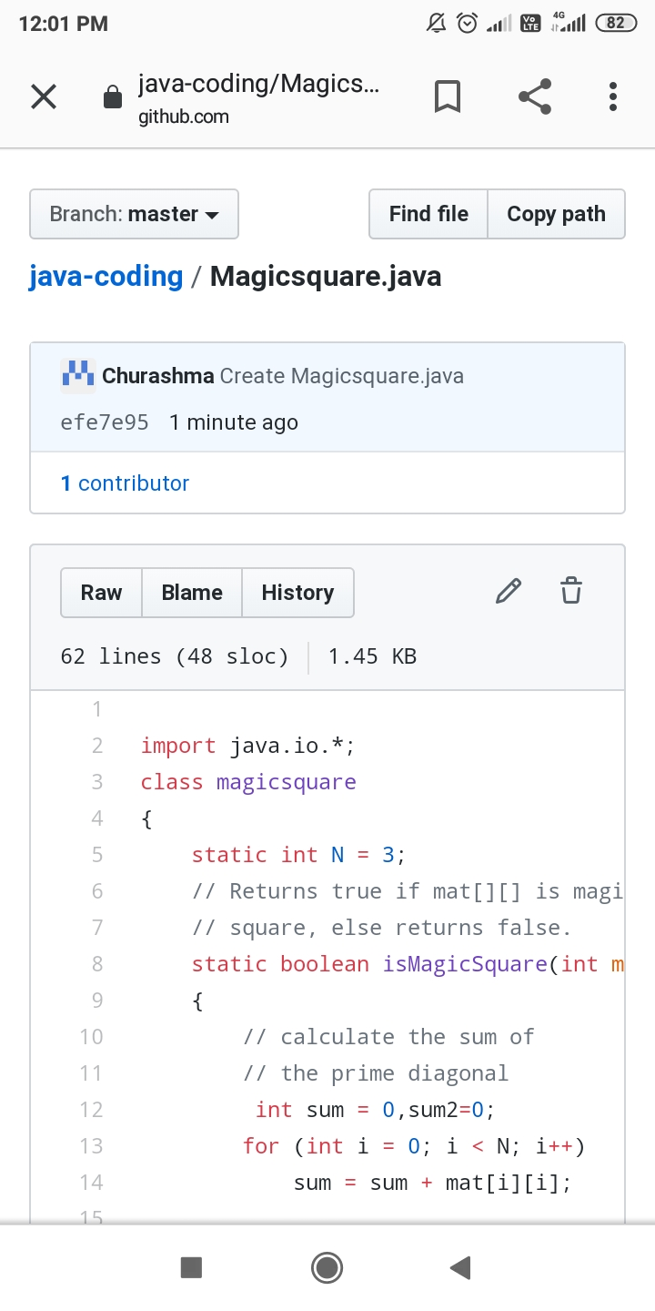

**Problem statement 2:** C Program to Generate All the Set Partitions of n Numbers Beginning from 1 and so on.

